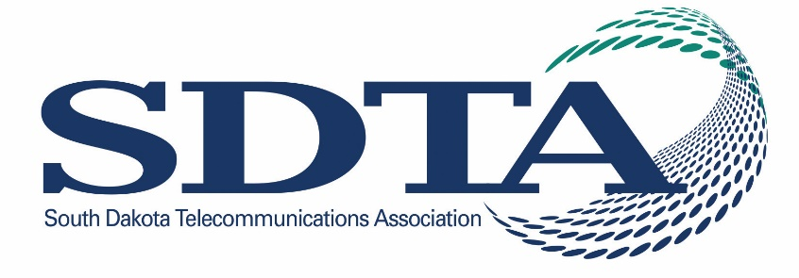
Marketing Professionals Workshop 2026
April 13 - 15, 2026
Highlands Event Center, Mitchell, SD

Some of the topics we are exploring for the open times include:
- Dangerous devices – What is it about the SuperBox and similar devices that pose a danger to our networks and customers?
- Just the facts: what are data centers and what role do they play in the larger technology landscape?
- Get along to go along: why office etiquette is important.
- How can AI be used in our “every day”
- An off-site visit to a business using advanced technology fueled by high-speed broadband.

Monday, April 13
1:00 pm Welcome – Kara Semmler

1:00 – 2:30 Lana Loken – Taking Care of You: It IS okay to say NO!

Life pulls us in many directions, and with the multiple roles we play, finding a healthy balance can feel overwhelming. This presentation guides participants in identifying their biggest challenges and recognizing the early signs of burnout. We will explore practical strategies for coping, building resilience, and self-care that are realistic and sustainable—designed to fit into even the busiest lives. YES – we’ll also talk about the power of saying NO as a vital part of protecting your well-being.

BREAK

2:45 TBD

3:45 – 4:15 pm TBD

5:00 – 7:00 pm Networking Social - Please join for hosted drinks and light food at Blarney’s

Tuesday, April 14
7:30 – 8:00 am Breakfast - provided
8:00 – 8:45 am Round Tables – Open Discussion
9:00 – 12:00 Andy Masters – Creating TRUE Customer Loyalty in the NEW Era of Customer Experience.
Andy illustrates why creating a culture of world-class customer experience more important NOW than any time in history, therefore we must now re-evaluate every touchpoint in the customer experience process.
- Interactive brainstorms on improving services through new innovations
- Anticipate challenges and complaints; then plan and prepare accordingly
- Embrace an empathy for those served at all times
- Be a light of positivity and solutions, during stressful and turbulent times.
- Manage customer expectations to improve quality, and decrease internal stress
- Increase customer confidence through communication, signage, and social media
Powerful service principles are based on Andy’s award-winning book “Kiss Your Customer“, as he proves that we must “create a transformation from doing a job to creating a bond”. Andy also shares examples from around the globe on how to create customer loyalty, avoid dissatisfaction, and improve reputation–including on social media. Our best customers are also our most effective–and least expensive marketing. Therefore, there will be no better opportunity than the NEW customer who will be visiting us tomorrow. Enjoy this timely, interactive, and impactful program which provides critical solutions to serve in today’s “high-expectation” world.
12:00 – 1:00 pm Lunch – provided
1:00 – 1:30 pm Marlene Bennett, Consortia Consulting – Regulatory Update.
1:30 – 2:30 pm TBD
3:00 pm Site Visit - TBD
GROUP DINNER

Wednesday, April 15
8:30 – 9:00 am Breakfast

9:00 – Noon Shawna Suckow - Small is Your Superpower! – Shawnasuckow.com

The way people buy, trust, and engage with businesses has changed faster in the last five years than in the last fifty...and the past six months have been record-breaking.
The marketing world has changed—and most big businesses didn’t get the memo. While big brands are still shouting through megaphones and polishing their media, small businesses are quietly winning hearts, attention, and loyalty. How? By doing something revolutionary: being human.
​
In this insight-packed presentation, Shawna unpacks the rise of the underdog in a trust-crisis era. She’ll reveal why today’s consumer is more skeptical, more distracted, and more craving of authenticity than ever before—and why that gives smaller organizations an unprecedented edge.
​
This keynote is your marketing reset button. It’s not about doing more—it’s about doing it differently. Whether you're a solo entrepreneur, a lean business team, or a scrappy organization trying to compete with the big guys, you'll walk away with practical strategies to:
​
- Stand out in a world overloaded with noise
- Build trust with audiences who’ve seen it all
- Become unforgettable (without becoming obnoxious)
- Apply Shawna’s Customer Brandships™ Framework to forge lasting loyalty through personality, presence, and permission to be real
Backed by behavioral data, packed with relatable humor, and rooted in Shawna’s decades of experience in buyer psychology, this keynote proves that small isn’t a liability—it’s the new marketing advantage.
​

