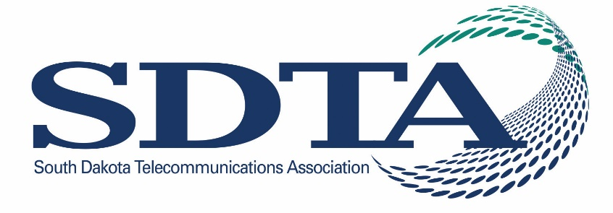
Office Professionals Workshop 2026
April 13 - 14, 2026
Highlands Event Center, Mitchell, SD

Some of the topics we are exploring for the open times include:
- Dangerous devices – What is it about the SuperBox and similar devices that pose a danger to our networks and customers?
- Just the facts: what are data centers and what role do they play in the larger technology landscape?
- Get along to go along: why office etiquette is important.
- How can AI be used in our “every day”

SESSION 1

Monday, April 13
1:00 pm Welcome – Kara Semmler

1:00 – 2:30 Lana Loken – Taking Care of You: It IS okay to say NO!

Life pulls us in many directions, and with the multiple roles we play, finding a healthy balance can feel overwhelming. This presentation guides participants in identifying their biggest challenges and recognizing the early signs of burnout. We will explore practical strategies for coping, building resilience, and self-care that are realistic and sustainable—designed to fit into even the busiest lives. YES – we’ll also talk about the power of saying NO as a vital part of protecting your well-being.

BREAK

2:45 TBD

3:45 TBD

5:00 – 7:00 pm Networking Social - Please join for hosted drinks and light food at Blarney’s

Tuesday, April 14
7:30 – 8:00 am Breakfast - provided
8:00 – 8:45 am TBD
9:00 – 12:00 Andy Masters – Creating TRUE Customer Loyalty in the NEW Era of Customer Experience.
Andy illustrates why creating a culture of world-class customer experience more important NOW than any time in history, therefore we must now re-evaluate every touchpoint in the customer experience process.
- Interactive brainstorms on improving services through new innovations
- Anticipate challenges and complaints; then plan and prepare accordingly
- Embrace an empathy for those served at all times
- Be a light of positivity and solutions, during stressful and turbulent times.
- Manage customer expectations to improve quality, and decrease internal stress
- Increase customer confidence through communication, signage, and social media
Powerful service principles are based on Andy’s award-winning book “Kiss Your Customer“, as he proves that we must “create a transformation from doing a job to creating a bond”. Andy also shares examples from around the globe on how to create customer loyalty, avoid dissatisfaction, and improve reputation–including on social media. Our best customers are also our most effective–and least expensive marketing. Therefore, there will be no better opportunity than the NEW customer who will be visiting us tomorrow. Enjoy this timely, interactive, and impactful program which provides critical solutions to serve in today’s “high-expectation” world.
12:00 – 1:00 pm Lunch – provided
1:00 – 1:30 pm Marlene Bennett, Consortia Consulting – Regulatory Update.
1:30 – 2:30 pm TBD

Office Professionals Workshop 2026
April 15 - 16, 2026
Highlands Event Center, Mitchell, SD

SESSION 2

Wednesday, April 15
10:00 pm Welcome – Kara Semmler
10:00 – 11:30 am Lana Loken – Taking Care of You: It IS okay to say NO!

Life pulls us in many directions, and with the multiple roles we play, finding a healthy balance can feel overwhelming. This presentation guides participants in identifying their biggest challenges and recognizing the early signs of burnout. We will explore practical strategies for coping, building resilience, and self-care that are realistic and sustainable—designed to fit into even the busiest lives. YES – we’ll also talk about the power of saying NO as a vital part of protecting your well-being.

11:30 TBD

12:30 – 1:30 Lunch

1:30 – 4:30 pm Andy Masters – Creating TRUE Customer Loyalty in the NEW Era of Customer Experience.
Andy illustrates why creating a culture of world-class customer experience more important NOW than any time in history, therefore we must now re-evaluate every touchpoint in the customer experience process.
- Interactive brainstorms on improving services through new innovations
- Anticipate challenges and complaints; then plan and prepare accordingly
- Embrace an empathy for those served at all times
- Be a light of positivity and solutions, during stressful and turbulent times.
- Manage customer expectations to improve quality, and decrease internal stress
- Increase customer confidence through communication, signage, and social media
Powerful service principles are based on Andy’s award-winning book “Kiss Your Customer“, as he proves that we must “create a transformation from doing a job to creating a bond”. Andy also shares examples from around the globe on how to create customer loyalty, avoid dissatisfaction, and improve reputation–including on social media. Our best customers are also our most effective–and least expensive marketing. Therefore, there will be no better opportunity than the NEW customer who will be visiting us tomorrow. Enjoy this timely, interactive, and impactful program which provides critical solutions to serve in today’s “high-expectation” world.

5:00 – 7:00 pm Networking Social - Please join for hosted drinks and light food.

Thursday, April 16
7:30 – 8:00 am Breakfast (provided)
8:00 – 9:00 am TBD
9:00 – 9:45 TBD
9:45 – 10:15 am Marlene Bennett, Consortia Consulting – Regulatory Update
BREAK
10:30 - 11:30 TBD

